 Graphics I – Lab 2

# Objective

The objective of today’s lab will be to implement what was learned in lecture. You will be creating your first primitive types in 2D space. We will be working mostly with points and lines. At this point you must have a strong understanding of how the first lab worked and you will also be expected to already have a few functions written to help with today’s lab. The most important of the functions will be:

* Clearing the back buffer to a certain color
* Drawing a pixel a certain color at a specific position

Today’s proof of concept will be to implement three line algorithms taught in lecture. The three line algorithms are:

* Bresenham
* Midpoint
* Parametric

You will be expected to make these algorithms into function calls because you ***WILL*** be calling them multiple times. It will also make it easier to debug your code ***AND*** assist a lab specialist with helping you in debugging your code. A term you will see repeatedly used **“Positive Slope Line”** refers to the algorithm only working with lines that slope in a positive direction in both x and y. (E.G. The line’s starting x value is lower than the ending x value AND the starting y value is lower than the ending y value).

The position for the Bresenham line is as follows:

* Line Start x0, y100
* Line End x499, y400

# Grading Breakdown

* 25% - Starfield
  + Draw approximately 2000-2500 “stars” for the background
  + Color them white
* 50% - Draw three lines using the three line algorithms
  + Bresenham points are given to you. Color the line red.
  + Midpoint line will be drawn 10 units below the Bresenham. Color the line green.
  + Parametric line will be drawn 10 units below the Midpoint. Interpolate the color from magenta to cyan.
* 75% - Randomized Position
  + Choose any line algorithm
  + Color is dependent on the line algorithm
  + Draw the start and end points as yellow pixels AFTER the line is drawn so we know the algorithm is working correctly.
  + Have a key press to randomize both start and end positions of the line.
  + Your algorithm must be robust enough to handle all octants.
* 100% - Randomized positions with all three line algorithms.
  + Similar to the previous checkpoint, use the next two line algorithms and randomize their start and end positions on button presses as well.
  + Color is dependent on the line algorithm. Stay consistent.
  + Don’t forget to mark the start & end points with yellow pixels.

# Above & Beyond

1. Adapt all three line drawing algorithms so there is no more than a ***single loop*** in each.
2. Modify the Bresenham & Midpoint algorithms so they never use any floats, only integers. The book has some very good advice on how to do this!

# Setup

# Example Images

50% 75%

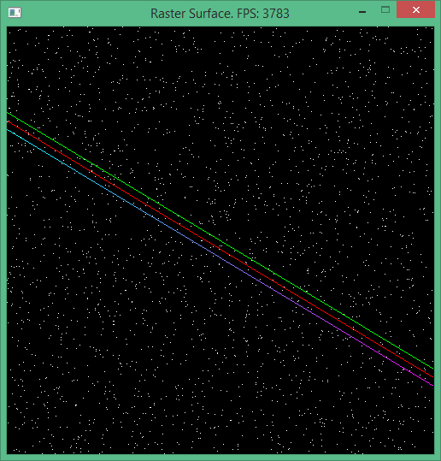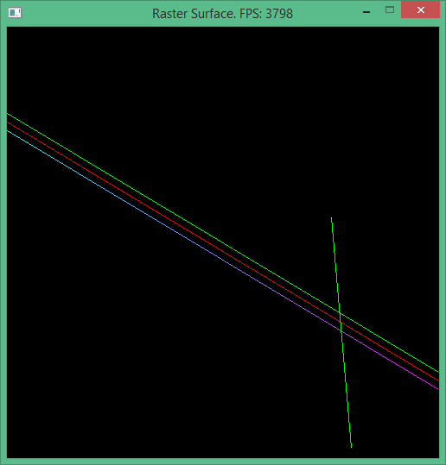

100%

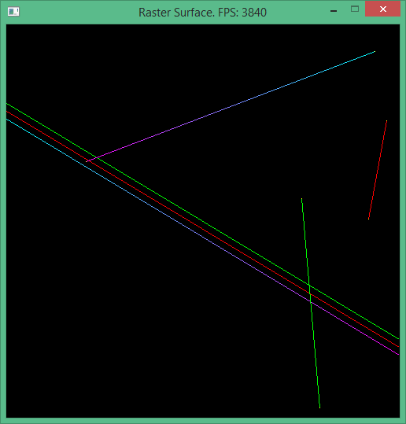

# Submission

Labs will be turned into student vfiler in the format of a zip file. The naming convention for the file will be ***Lastname.Firstname.Lab#.zip***. The contents of your zip file should only contain source files and shaders you have written. We would like these submissions to be as small as possible in order to accommodate space for everyone. If you fail to submit properly *you will lose points* on your grade. Even if it was a visual check-off.

# Frequently Asked Questions

**Q**: My midpoint line is not working properly, it says I am above the line when I am actually below it.

**A**: The implicit line equation is based on the gradient, the direction of travel affects what “up” is.